**DAILY ONLINE ACTIVITIES SUMMARY**

|  |  |  |  |  |  |  |  |
| --- | --- | --- | --- | --- | --- | --- | --- |
| **Date:** | **29-05-2020** | | | | **Name:** | **B.A.SOHANKUMAR** | |
| **Sem & Sec** | **4TH SEM A** | | | | **USN:** | **4AL18CS013** | |
| **Online Test Summary** | | | | | | | |
| **Subject** | | **OPERATING SYSTEMS** | | | | | |
| **Max. Marks** | | **30** | | **Score** | | **28** | |
| **Certification Course Summary** | | | | | | | |
| **Course** | **INTRODUCTION TO R** | | | | | | |
| **Certificate Provider** | | | **GREAT LEARNING ACADEMY** | **Duration** | | | **2.5 HOURS** |
| **Coding Challenges** | | | | | | | |
| **Problem Statement:1:Write a java program to find size of the largest '+' formed by all ones in binary matrix.**  **Problem Statement:2:Write a C program to generate first N Armstrong numbers.** | | | | | | | |
| **Status: EXECUTED** | | | | | | | |
| **Uploaded the report in Github** | | | | **YES** | | | |
| **If yes Repository name** | | | | **LOCKDOWN CODING** | | | |
| **Uploaded the report in slack** | | | | **YES** | | | |

**ONLINE TEST DETAILS:**

1. The test was from module 2 of OPERATING SYSTEM(18CS45).The time duration was 45 minutes from 09.00am to 09.45pm.There were 30 questions of mcq type.Score I received is 28/30.

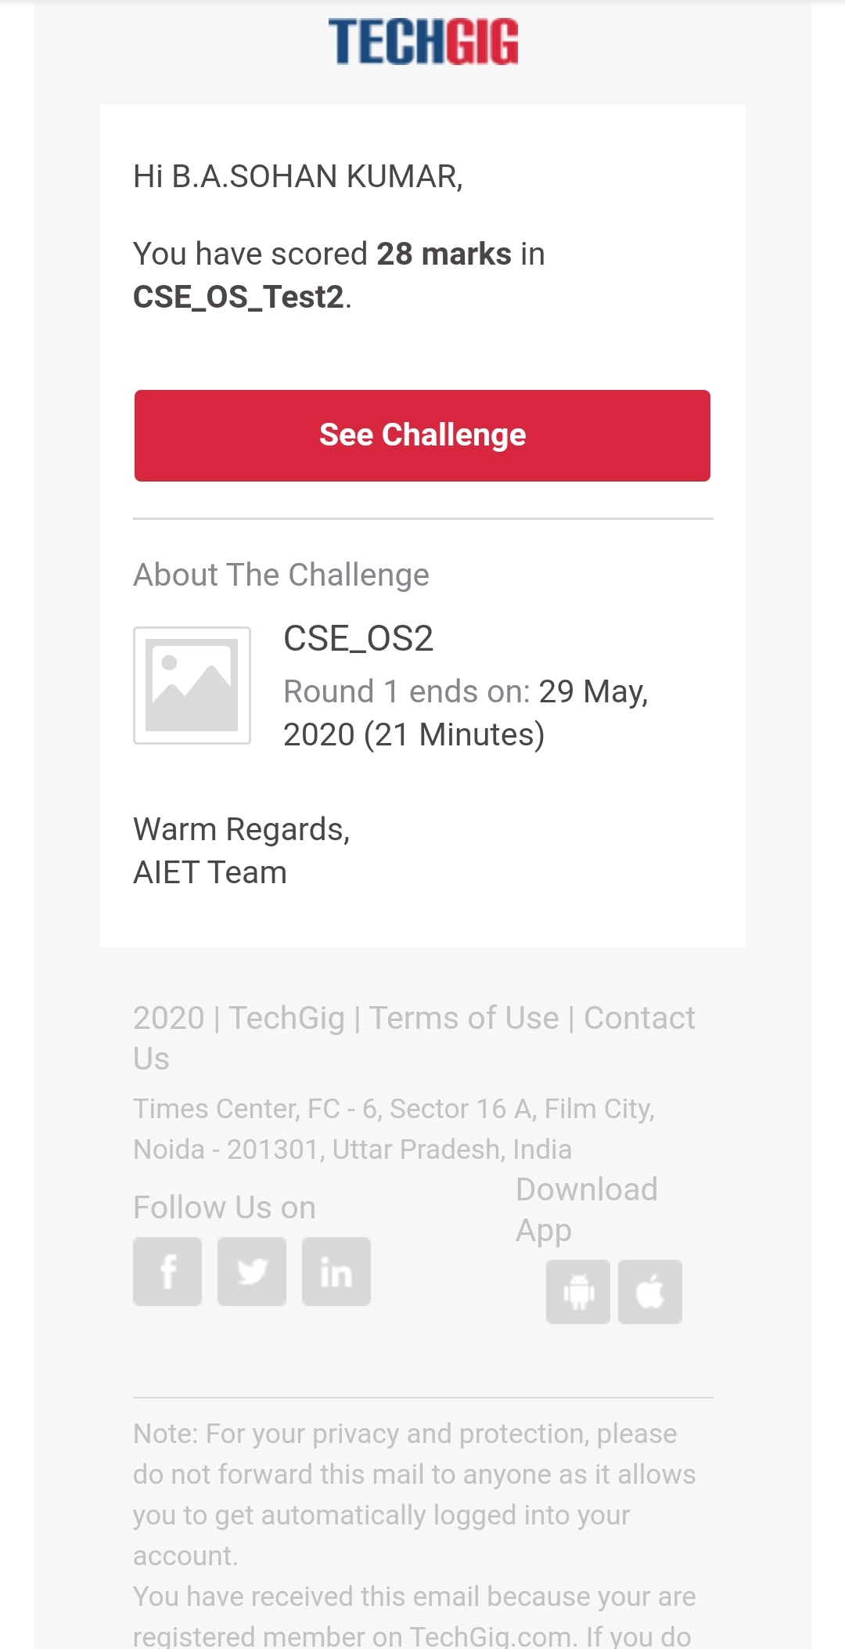

SNAPSHOT: OPERATING SYSTEM

**CERTIFICATION COURSE DETAILS:**

COURSE: INTRODUCTION TO R,In this present highly competitive and global environment, any professional and progressive organization that aims to survive, grow significantly in the marketplace and then sustain the growth must unshackle itself from ad-hoc ways of looking at data. Instead, it should use analytic tools for converting data into information for effective decisions and strategy formulation.

Today completed with topics of R_Overview & Preliminary Steps,Data Types,Data Structures,Importing data,Data Manipulations,Sorting and Merging,Data Summaries,Exporting Data,Plots_Numeric,Plots_Categorical,Plots_Combinations,Export Plots,Case Study : House Prices.And completed quiz 1.

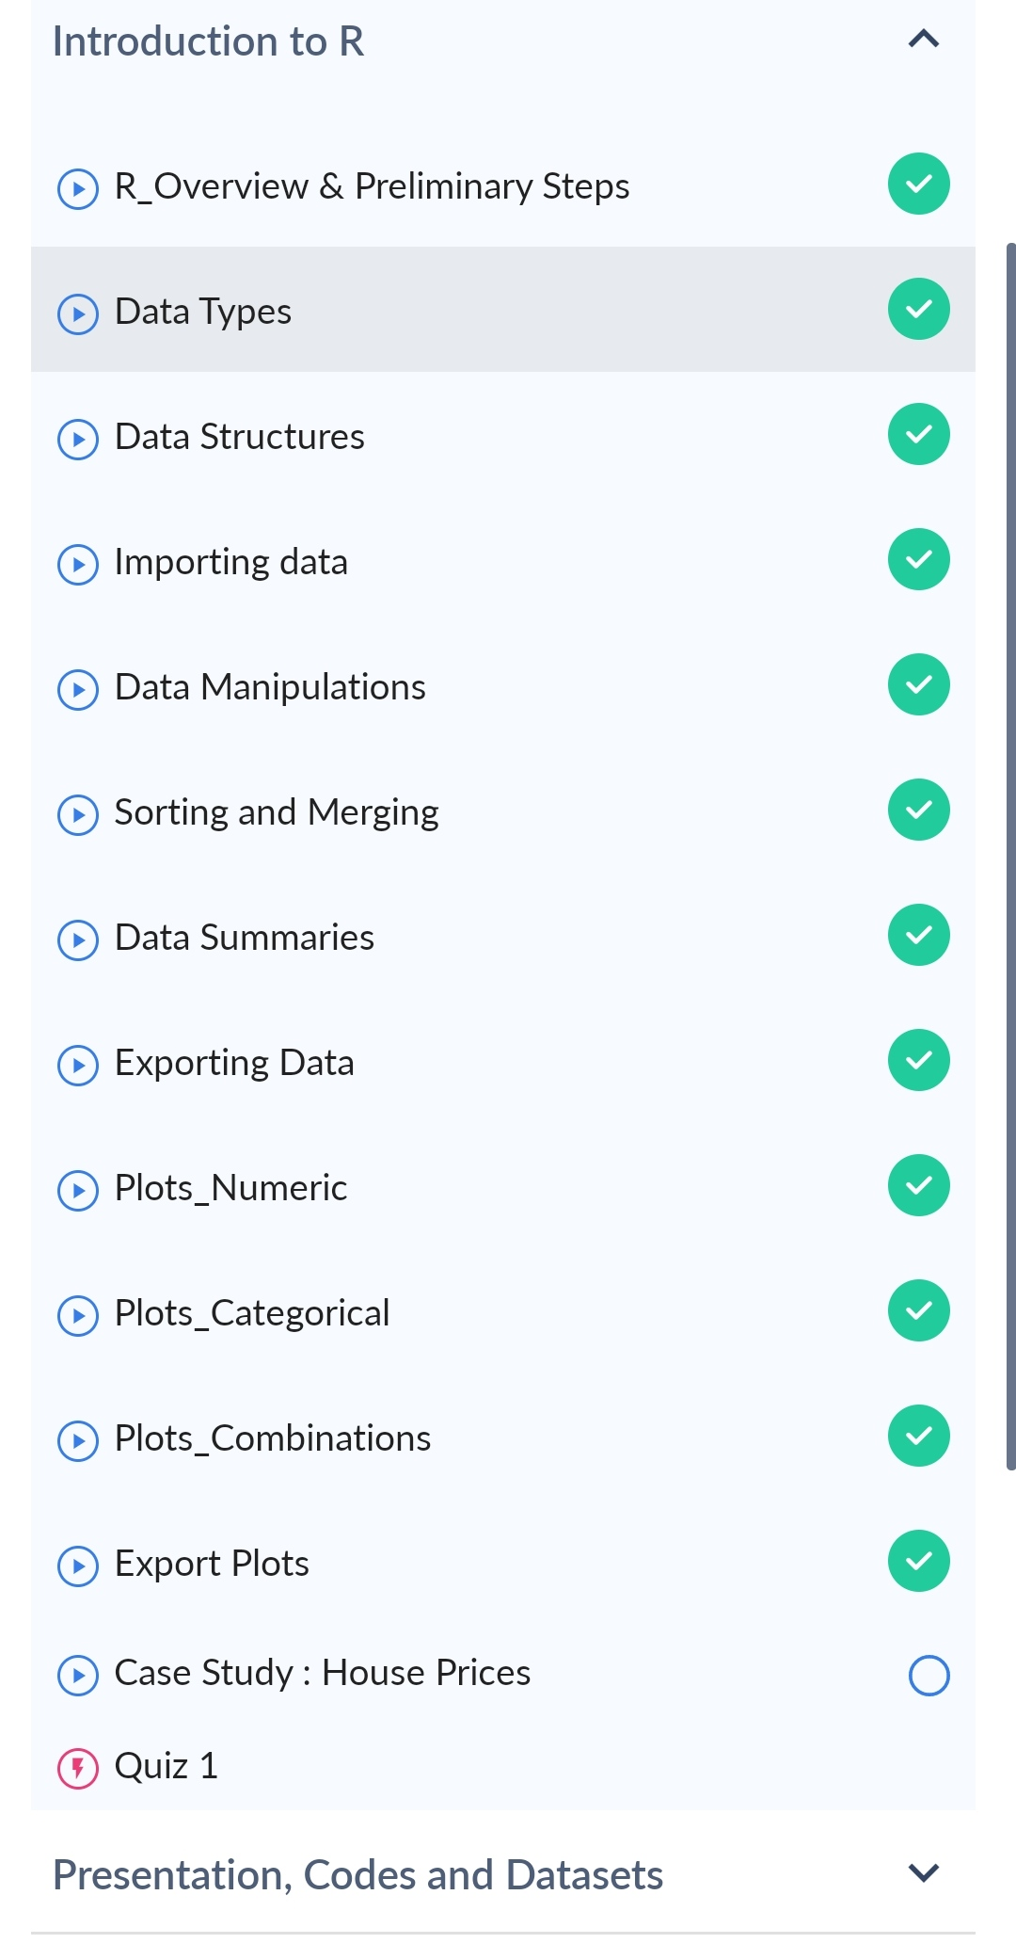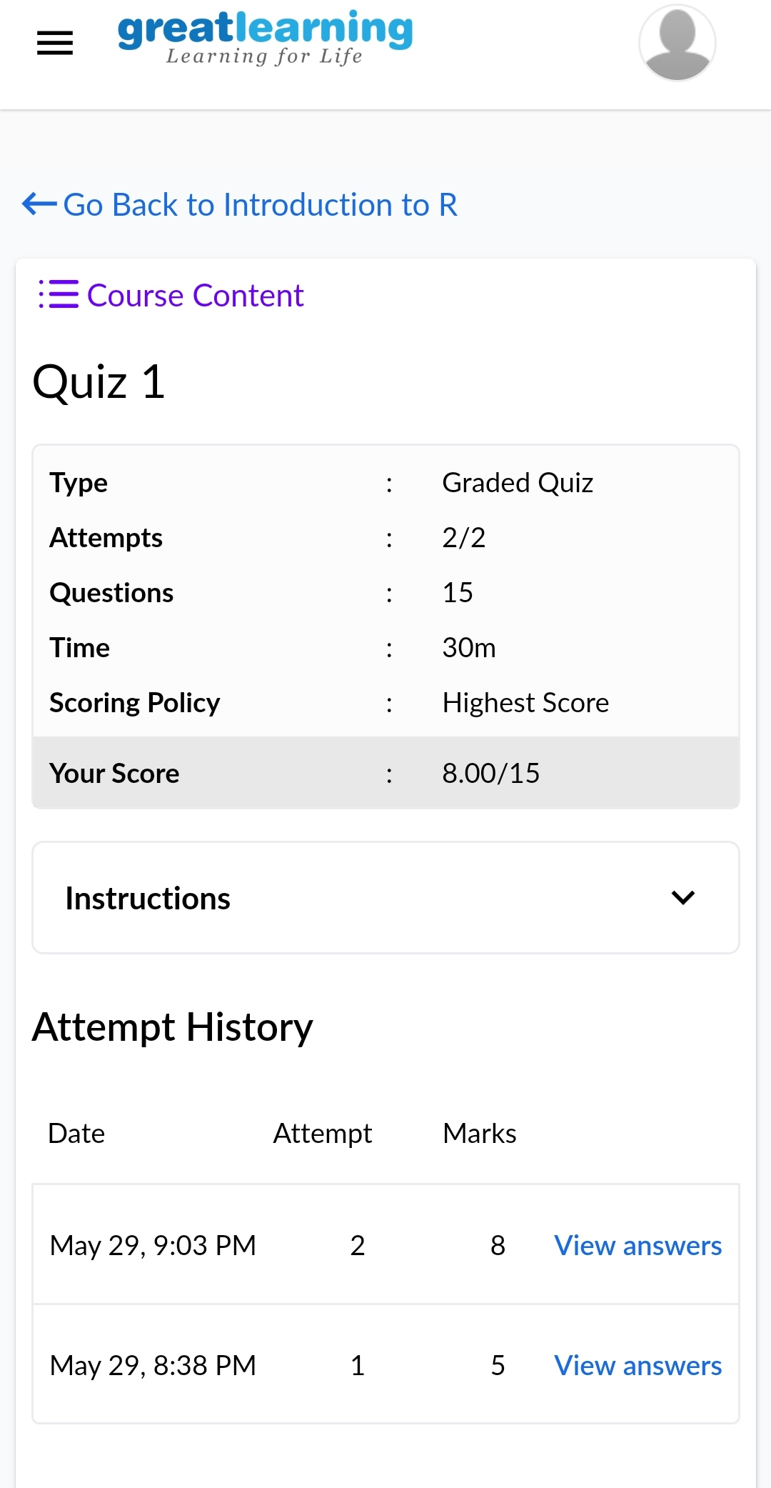

**CODING CHALLENGES:**

1.:Write a java program to find size of the largest '+' formed by all ones in binary matrix.Given a N X N binary matrix, find the size of the largest ‘+’ formed by all 1s.

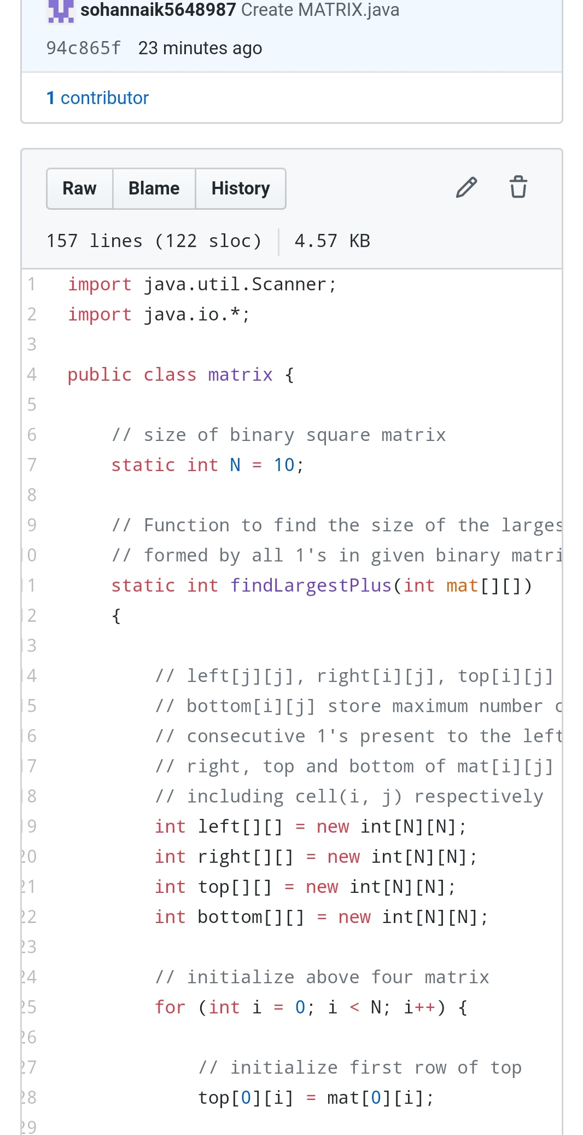

2.Write a C program to generate first N Armstrong numbers.

Armstrong number is a number that is equal to the sum of cubes of its digits. For example 0, 1, 153, 370, 371 and 407 are the Armstrong numbers.

Example 1:Let's try to understand why 153 is an Armstrong number.

153 = (111)+(555)+(333),where:(111)=1,(555)=125,(333)=27,So:1+125+27=153.

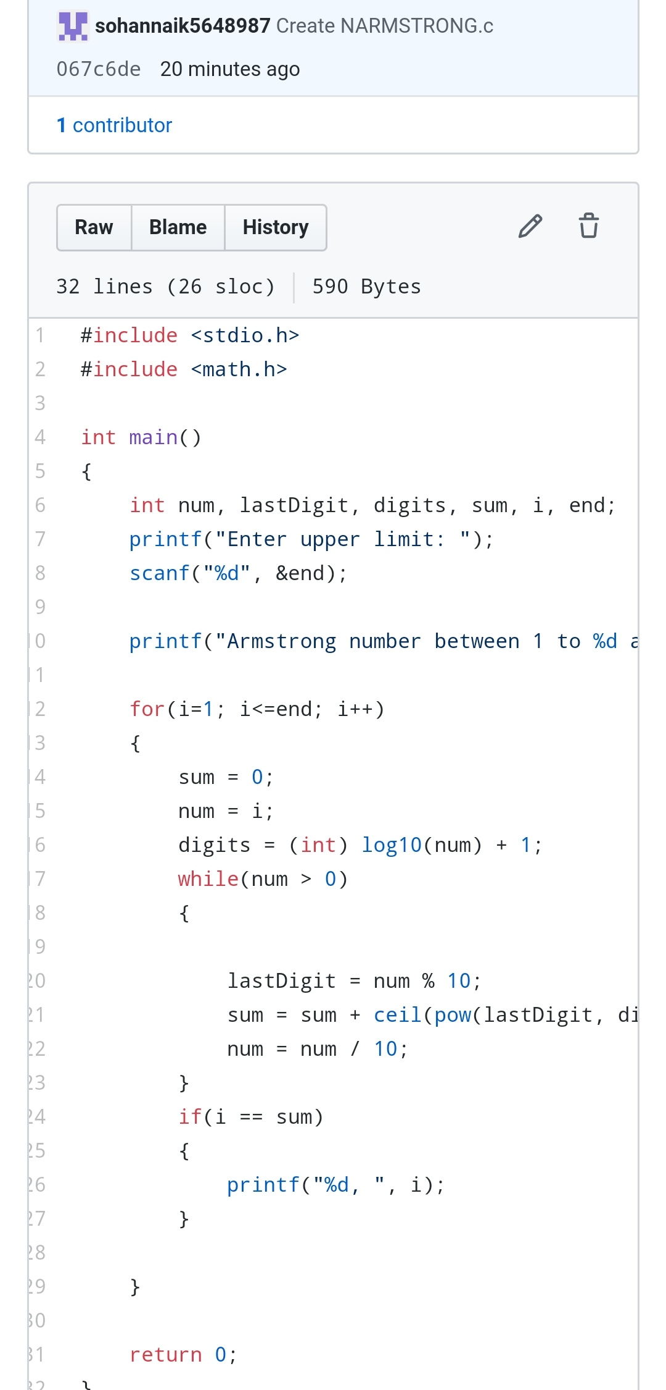

REPOSITORY LINK:1.https://github.com/sohannaik5648987/C-CODING

2.https://github.com/sohannaik5648987/JAVA-CODING